Name____________________________________________________________________  
Lab: Surface Tension-- Part One

*Purpose:* The purposes of this lab are to gain a better understanding of surface tension, especially the surface tension of water as it compares to other liquids; explore the role of surfactants; review the components of high-quality data tables and graphs; and introduce statistical analysis, including mean, standard deviation, standard error of the mean, and error bars.

*Explore:* using a disposable pipette, drop water onto a penny, **recording** your observations here in words and a labeled picture:

*Background:*

Surface tension is the tension of the surface film of a liquid caused by the attraction of the particles. This is affected by structure of the molecules and their relative polarity.

Here are some chemical structures:  
  
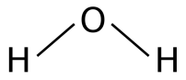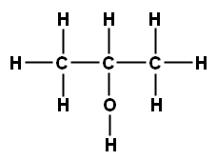

water

isopropyl alcohol,   
also known as rubbing alcohol

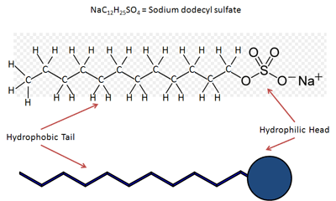

sodium dodecyl sulfate,   
an active ingredient in dish soap, which is a surfactant

Predict: After considering the relative polarity of each molecule, past experiences with these substances, and the behavior of the water when dropped onto a penny, predict the *relative* number of drops (so not actual numbers, but rather which liquid will support the most drops cohering (piling up), the fewest, and the median number of drops) of each liquid (water, isopropyl alcohol, and water mixed with dish soap) that will be able to cohere before “overflowing”. **Write** your prediction, and then **support** your prediction with reasoning (that’s a scientific way to say, “*what* do you think will happen, and *why* do you think that?”)

*\*\* Think about the difference between a prediction (like you made above) and a hypothesis. Then, look up what a NULL hypothesis is, and try to formulate one related to your prediction)\*\**

**Null Hypothesis:**

*Data Collection and Analysis:*   
Drop each liquid onto a penny, counting the number of drops that cohere before overflowing. Run five trials of each liquid, and **record** your data in Table 1. Note: please consider ways to make this a tightly-controlled experiment; that is, ways to limit the variability of each trial so that we are confident that the results are due to the differences in the liquids, and not in the way you performed each trial. Please **list** theways that your group controlled this experiment here:

**Table 1. Number of Drops of Various Liquids Able to Cohere on a Penny**

|  |  |  |  |  |  |  |
| --- | --- | --- | --- | --- | --- | --- |
| **Substance** | **Number of Drops on the Penny** | | | | | |
| **Trial #1** | **Trial #2** | **Trial #3** | **Trial #4** | **Trial #5** | **Mean** |
| **Tap Water** |  |  |  |  |  |  |
| **Isopropyl Alcohol** |  |  |  |  |  |  |
| **Tap Water with Dish soap** |  |  |  |  |  |  |

***Note the title of my data table; it tells the viewer exactly what kind of information they will find in the table, and helps them understand the purpose of the experiment. Just like you don’t name a book “book” or a song “song”, you don’t name a data table “data table”. However, because I happen to already know there will end up being more than one table as a part of this lab, I have labeled it “Table 1.” to make it easier to reference later.***

*Graphical Representation of Results:* On the grid provided on the next page, please **construct** a bar graph of your results. Remember your independent variable is represented on the X axis, your dependent variable on the Y axis, all axes must contain labels with units (if appropriate) and be properly scaled. You should use at least ¾ of the graph to display your data. Also, graphs are considered figures, and need meaningful titles (on posters or projections, like PowerPoints) or figure legends (on papers); I’ve written the figure legend for this one for you.



*Figure 1. A comparison of the mean number of drops of various liquids that cohered on a penny before overflowing (five trials were performed per liquid).*

*Conclusion:* So, if you needed to make a conclusion based on the means of your data, would you conclude that your prediction is supported or is not supported by your data (notice I didn’t use words like your prediction was “proven right” or “proven wrong”—“prove” is a pretty strong word in science, so we don’t use it very often, just like it is incredibly rare that you actually “discover” something)? With that in mind, **state** your conclusion, using the “claim-evidence-reasoning” approach.

Lab: Surface Tension—Part Two (parts one and two are due together as an “all components” assignment)

Statistical Analysis: Please use google sheets to perform the calculations necessary to **complete** Table 2.

**Table 2. Descriptive Statistics on the Number of Drops of Various  
 Liquids Able to Cohere on a Penny**

|  |  |  |  |
| --- | --- | --- | --- |
| **Statistic** | **Liquid Tested** | | |
| Water | Isopropyl Alcohol | Tap Water with Dish soap |
| Mean |  |  |  |
| Standard Deviation |  |  |  |
| Standard Error of the Mean (SE) |  |  |  |
| 2 SE |  |  |  |
| Mean  + 2 SE |  |  |  |
| Mean  - 2 SE |  |  |  |

Graphical Representation of Data: Please **refine** the graph you made earlier to include error bars that represent +/- 2 SE. Also, **improve** the figure legend by adding this sentence: Error bars represent   
+/- 2 SE.

Conclusion: Please **conclude** if the surface tensions of the three liquids are or are not statistically significantly different from each other; use the means and error bars to **justify** your conclusion (again, use the claim-evidence-reasoning format to guide you).